**TIME AND PRODUCTIVITY ANALYSIS**

**PROBLEM DESCRIPTION:**

Productivity Analysis is conducted to identify areas for potential productivity improvement projects based on statistical data collected during the analysis. The analysis also pinpoints areas of delays and interruptions that cause loss of productivity.

In any productivity improvement initiative is to understand the current state of the operation. Productivity analysis provides baseline indicators that will also yield data which will be used to determine possible productivity improvement objectives and potential cost savings.

**REQUIREMENTS:**

LANGUAGES:

HTML,CSS,PHP

DATABASE:

MYSQL

SOFTWARE:

XAMPP

**SCREEN DETAILS:**

Common screens like Login and Dashboard will been done as a general process.

1. Graphical View
2. Report

**GRAPHICAL VIEW:**

The employee work details from the works table has been converted to graphical view.It can be used to identify the status of the project whether it is completed or it is in pending state.

**REPORT:**

Report is generated based on the data present in the works table.

**DATABASE DESGIN:**

1. **REGISTER:**

firstname varchar(50)

Middlename varchar(50)

lastname varchar(50)

Email varchar(200)

Password varchar(8)

Confirmpassword varchar(8)

Phonenumber text

Dat e_of_registeration timeatamp

1. **WORKS:**

Task varchar(100)

Projecttitle varchar(1000)

Description varchar(1000)

Starttime datetime

Endtime datetime

Status varchar(500)

**INPUT:**

The employee work details has been stored in the works table.The works table consists of task,projecttitle,description,starttime,endtime,status.

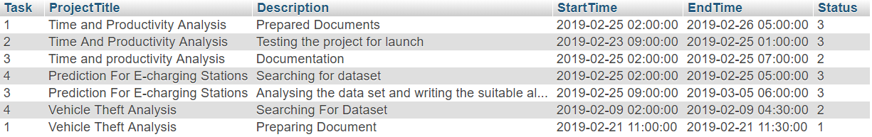

**OUTPUT:**

The data from users table is retrieved and it is graphically represented .So that on can identify where time is used unneccessarily.

